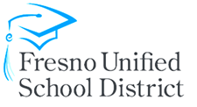
Instructional Continuity
Fresno Unified School District is committed to ensuring the health and well-being of students and staff and providing a safe, secure learning environment for all. The following are resources for students and families to ensure that they may continue their learning while at home during school closures.

Dear Early Learning Families,
The district is implementing, effective immediately, a series of steps based on recommendations from public health officials to make sure that the district’s youngest learners remain safe and healthy. To ensure that learning continues at home, the Early Learning Division is sharing some learning resources with your family. These resources are designed to support your child’s learning at home or when they are not in school.
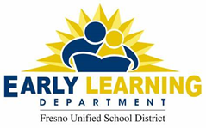
Students and educators work hard to create special learning opportunities for you child each day. In the meantime, we encourage you to visit the Fresno Unified Early Learning website for parent resources and valuable information related to your child’s health and learning.
Sincerely,
Deanna Mathies, Executive Officer
Early Learning Department, Fresno Unified School District

General Resources
- Access to FUSD Early Learning Resources
  - Early Learning Department homepage: https://www.fresnounified.org/dept/earlylearning
- Access to FUSD Digital Library
  - SORA app available at https://soraapp.com/home
- Literacy, Math and Science Education
- AIMS Math and Science: https://www.aimscenter.org/resources
- Scholastic:https://www.scholastic.com/parents/school-success/home-learning-resources.htm
- Learning sounds A to Z: https://www.allaboutlearningpress.com/letter-soundsapp/
- Wil books https://www.wilbooks.com/wilbooks-free-resources
- Sesame Street:
  - Sesame Street: https://www.sesamestreet.org/
  - Sesame Street in Communities: https://sesamestreetincommunities.org/
- Physical Development
  - Cosmic Kids Yoga: https://www.youtube.com/user/CosmicKidsYoga

